**Project Design Phase-II**

**Technology Stack (Architecture & Stack)**

|  |  |
| --- | --- |
| Date | 08 May 2023 |
| Team ID | NM2023TMID11499 |
| Project Name | Dissecting the Digital Landscape : A Comprehensive Analysis of Social Media |

**Technical Architecture:**

The Deliverable shall include the architectural diagram as below and the information as per the table1 & table 2

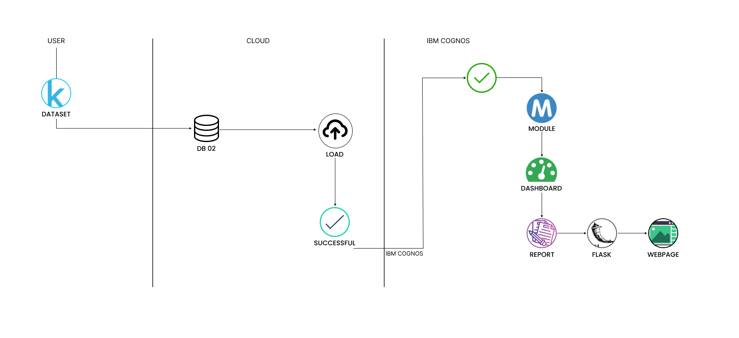**Table-1 : Components & Technologies:**

|  |  |  |  |
| --- | --- | --- | --- |
| **S.No** | **Component** | **Description** | **Technology** |
|  | Data Collection | Gathering social media data from various platforms | APIs, Web scraping |
|  | Data Module | Creating a module to process and manage collected data | Python, Pandas, SQL |
|  | Visualization | Creating visual representations of analyzed data | Matplotlib, Plotly, D3.js |
|  | Dashboard | Developing a web-based dashboard to present data visually | Flask, HTML, CSS, JavaScript |
|  | Flask Integration | Embedding the dashboard within a Flask application | Flask, Jinja2 Templates |
|  | Scalability | Designing architecture for scalability and handling large datasets | Distributed systems, Cloud infrastructure |
|  | Scalability | Implementing security measures for data protection and access control | Encryption, Authentication, Authorization |

**Table-2: Application Characteristics:**

| **S.No** | **Characteristics** | **Description** | **Technology** |
| --- | --- | --- | --- |
|  | Open-Source Frameworks | Utilizing open-source frameworks for social media analysis | Apache Hadoop, Apache Spark, Python |
|  | Security Implementations | Implementing security measures to protect data and user privacy | Encryption, access controls, secure protocols |
|  | Scalable Architecture | Designing an architecture that can handle growing data volumes and user activity | Distributed computing, cloud infrastructure |
|  | Availability | Ensuring the platform is accessible and available to users | Load balancing, fault tolerance mechanisms |
|  | Performance | Optimizing the system for efficient and fast data processing | Parallel processing, optimized algorithms |